Q4
- Wait() and waitpitd()
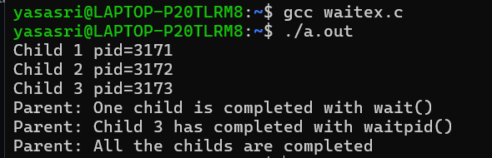

b)zombie process
